Experiment – 4

Data Modelling and Form Design for a Business Application in Zoho Creator

Aim:
To design a suitable data model and user-friendly forms for a business application using Zoho Creator.

Definition:
Data Modelling is the process of organizing data into entities, fields, and relationships so that it can be stored and managed efficiently.

Form Design is the process of creating input forms with appropriate fields and controls to collect data from users.

Procedure:

- Log in to the Zoho Creator platform.
- Create a new application for a business requirement.
- Identify the important entities and information required by the application.
- Create forms for entering and storing the required data.
- Add suitable fields such as text, number, date, email, dropdown, and lookup fields.
- Define relationships between related data using lookup fields.
- Arrange the fields in a logical and user-friendly order.
- Set required fields and appropriate validation rules.
- Save and test the forms by entering sample records.
- Verify that the entered data is stored and displayed correctly.

Output:

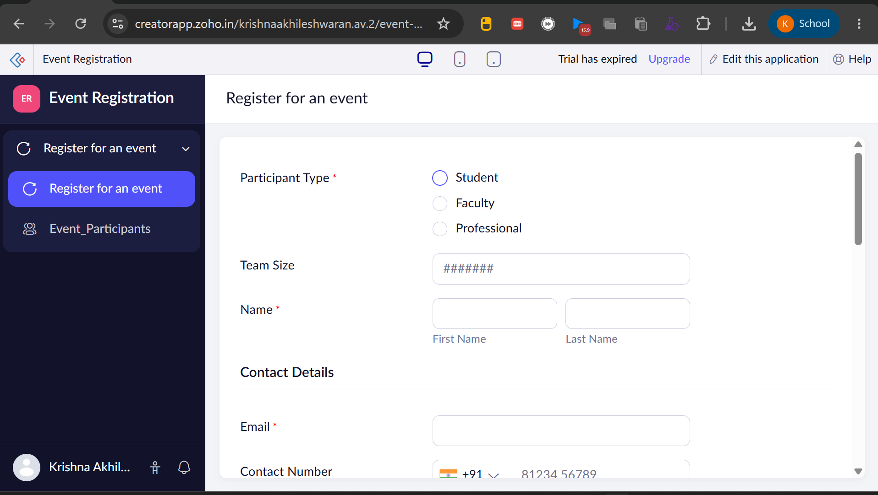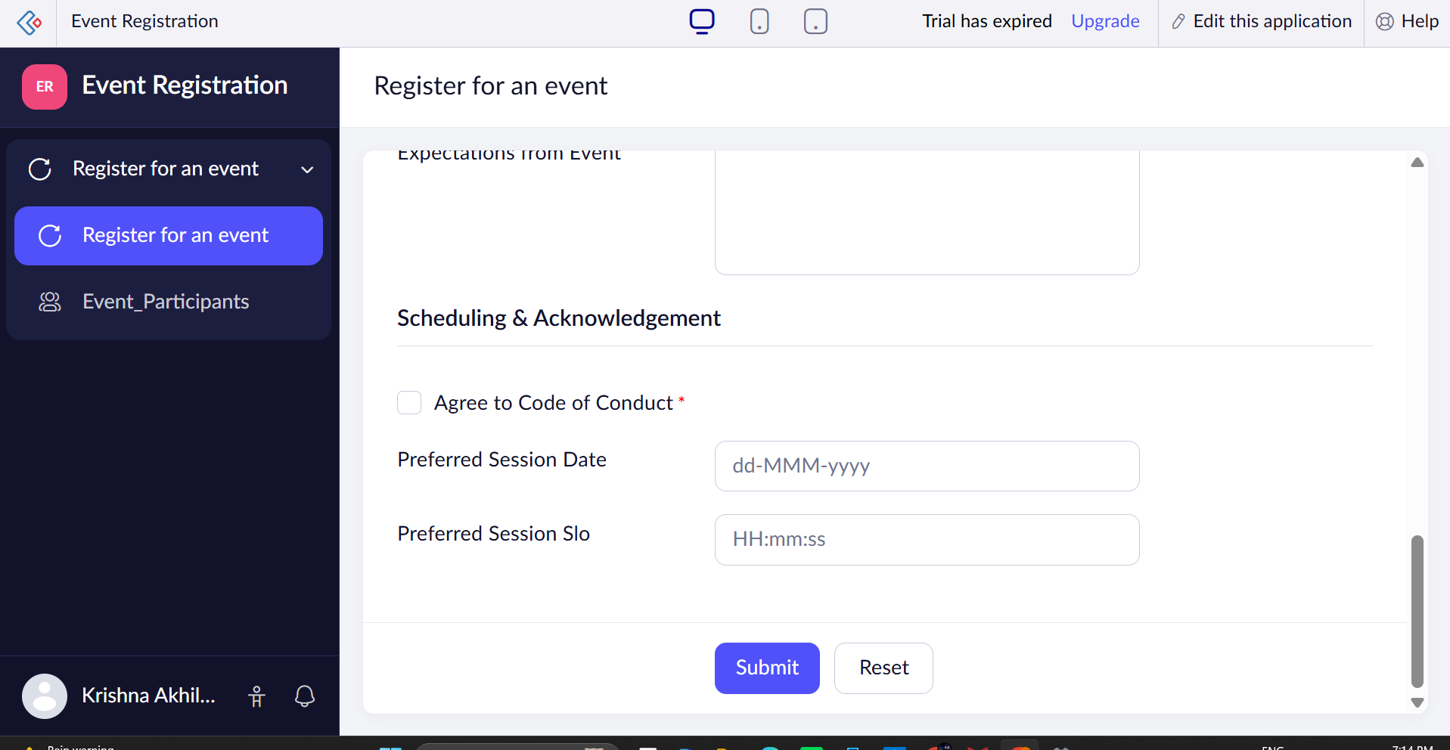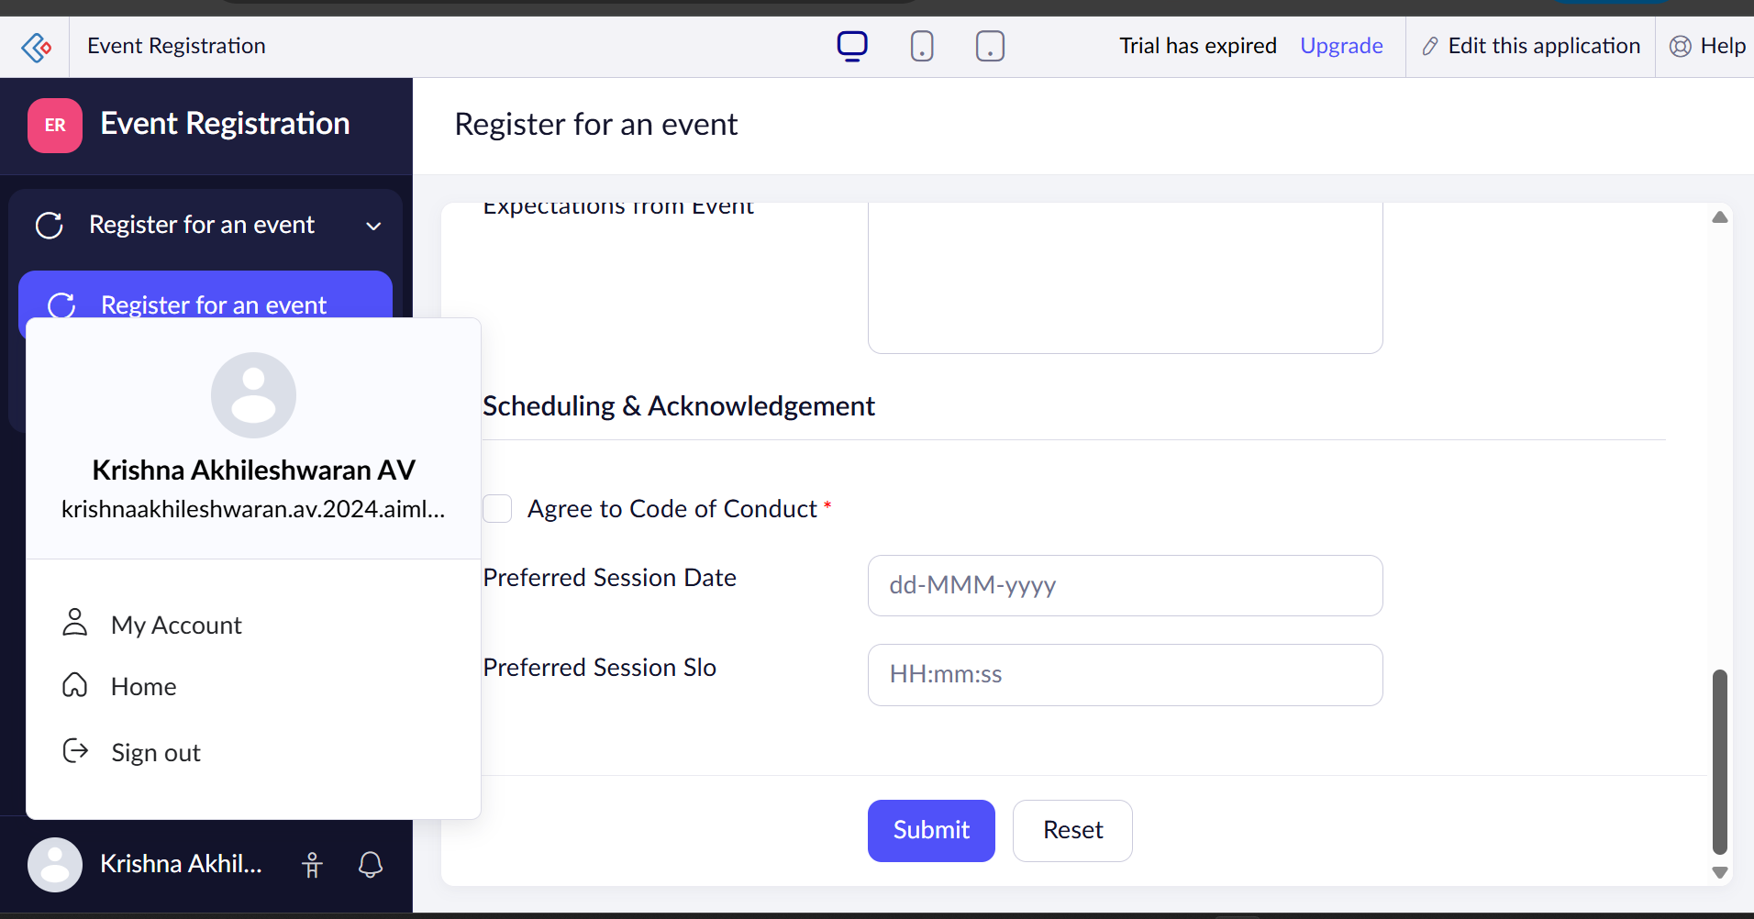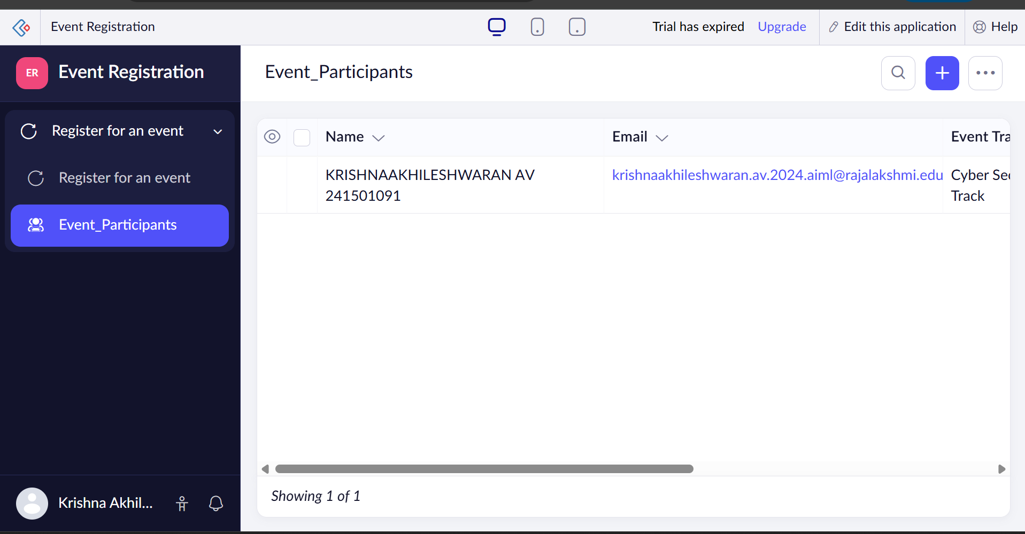

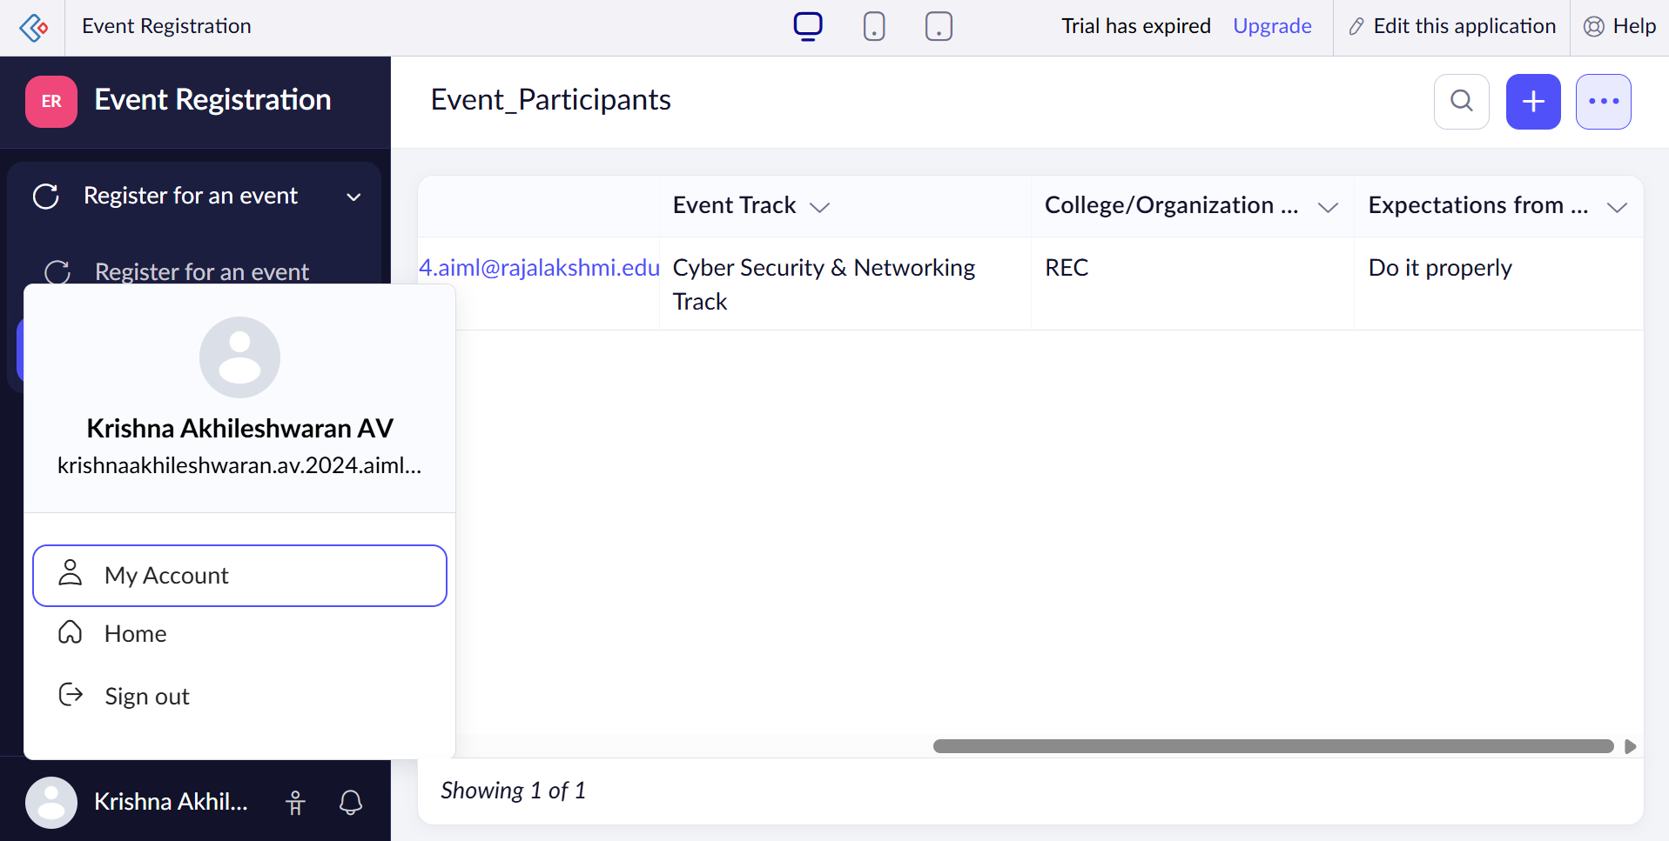

Result:
The data model and forms were successfully designed in Zoho Creator. The required fields, relationships, and validations were configured to support efficient data collection and management for the business application.

